Tab 1
Docker Task

Task Description:

Install docker on EC2 and explore the docker commands (docker images, containers, volumes, network)

Install docker on EC2

Docker is up and running

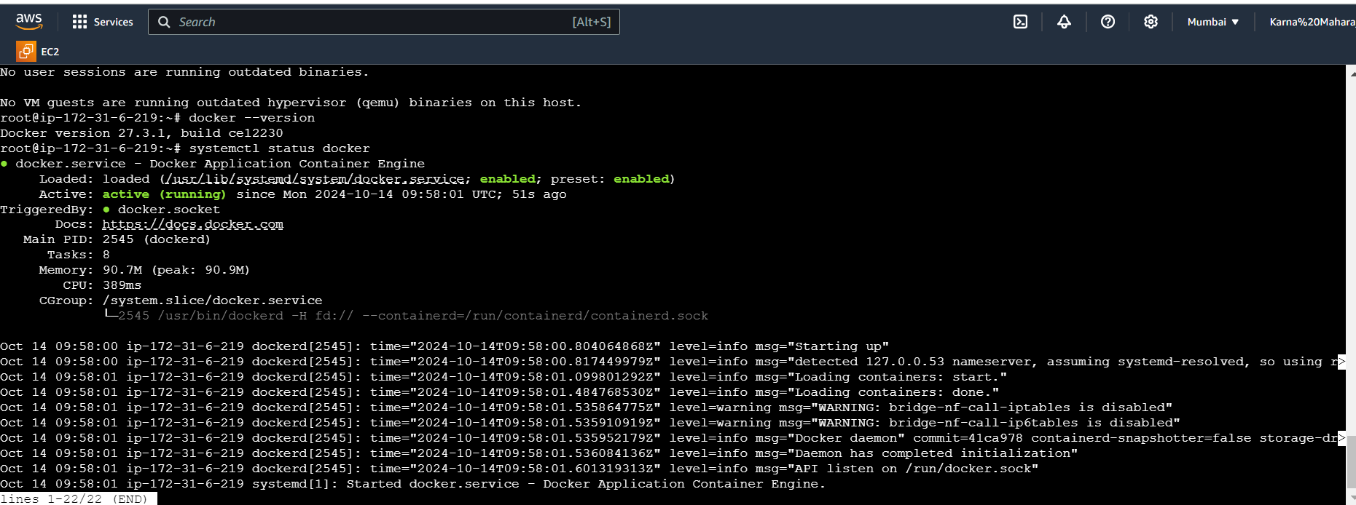

docker commands (docker images, containers, volumes, network)

